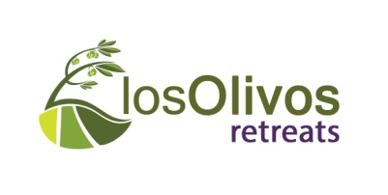

Los Olivos booking form
Your Name(s)
Address
Telephone
Mobile
Email
Do you wish to receive information from losOlivos in the future? Y/N

Your Payment details: (If you prefer to give us these details over the phone just give us a call at 01865 685024)

Payment type* | Bank transfer / Debit or Credit Card
Card type* | Visa / Mastercard / Maestro
Card Number
Expiry date

I authorise you to debit my account with the deposit amount (25% of stay cost) of: ________ € (Euros)

Your booking details:

Name of Retreat (Ubeda / Malaga)

Accommodation | * Single / Twin / Double
Dietary needs (if any) | * None / Vegetarian (+fish) / Gluten or Lactose free  Gluten & Lactose free diets will incur a €5/day supplement.  (Please note that we are not able to cater for Vegan diets)
Special needs | please provide us with any information (medical condition, disability etc. ) that will help us to make your stay as comfortable as possible.
Ubeda Retreat - transfers  Are included in the price, and there will be a pick up from the Malaga train station at 14.30 on the first day of the retreat.  The transfer back on the last day will leave Ubeda at 10.00, arriving back at the Malaga station around 13.30. | Segovia Retreat - transfers  There will be a transfer organised from Madrid, included in the price of retreat. Details TBC.

*delete as appropriate
** In order to confirm your booking it is necessary to pre-pay a 25% deposit of the total amount, if booking more than 30 days prior to the reservation, or the full amount if booking less than 30 days.
I agree with the booking terms and conditions – yes / no
www.losolivosretreats.com

